Please find Metrics sheet link in below path:
\\punnfil02\discover project$\QL_Activities\Metrics_2021
- We need to update Data Sheet tab
- Steps: Copy previous month Metrics sheet and rename it by changing Month/Year.
- Update Month
- We need to update counts for Backlog tickets, No. of tickets accepted by user at first time, No. of user support tickets received/created at First time, No of Tickets delivered in the month, No. if tickets responded with in SLA, No of tickets met resolution time SLA for the month, and Total actual effort.
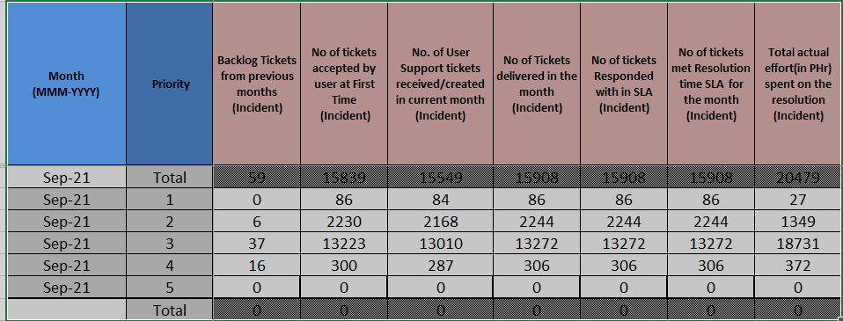
- Please refer sheet shared in Discover VM to get counts through Service now.
Note: Final counts shout be in hour so we need to convert and then need to fill counts.
- Total actual effort is calculated as Resolved time - Open time post adjustment {[No action taken/Mass closed 10 mins] [P1 and P2 reassignment INC 30 mins | P3 and P4 reassignment INC 1 hour][P4 incident time resolved time has been approximated to 4 hour]}

- Once update is done, Click Extract outliers.
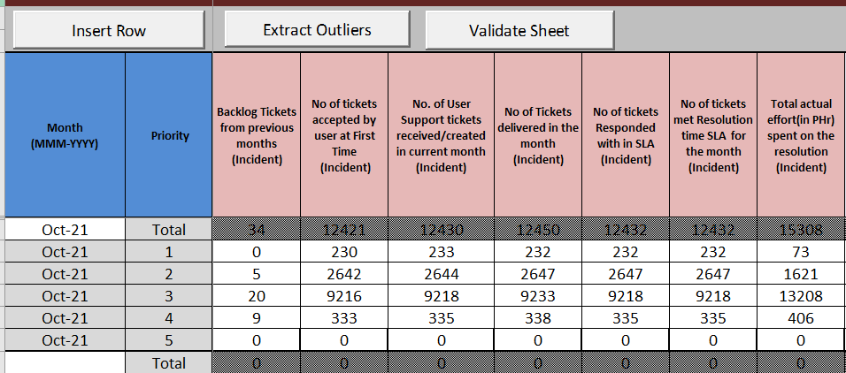
- Go to Outliers Sheet tab
- We need to update Reason and Root causes in case of less Incident productivity.
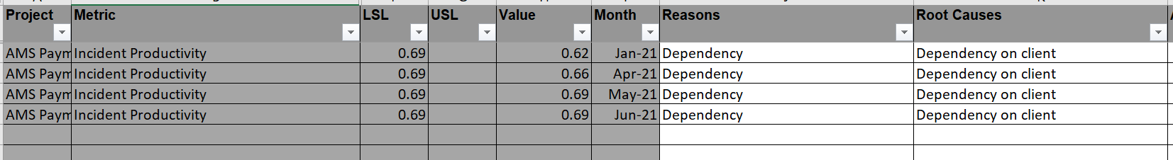

- Go to Data Sheet tab. Click on Validate Sheet.
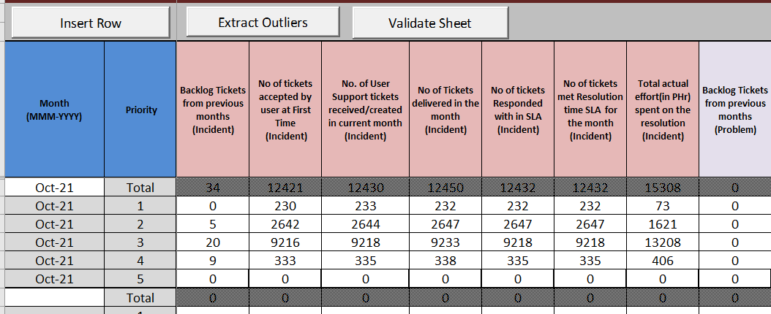
We will get pop up, Click OK.
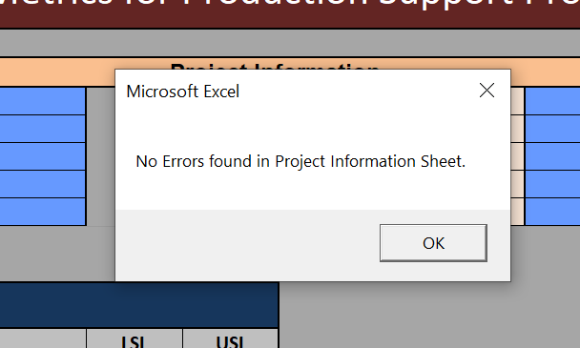
Click OK
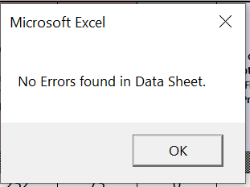
Click Ok
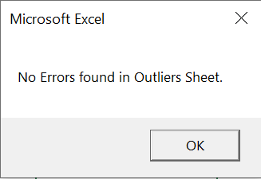

Sheet is Completed.
Please find path of Metrics Sheet for Oct 2021 below
Sheet name: Metrics_PSLC_BCM-US_Discover_AMS_Payments_Project_Oct_2021
\\punnfil02\discover project$\QL_Activities\Metrics_2021\Oct'21\AMS

